Extension Enhancement
- Generate jsonl file
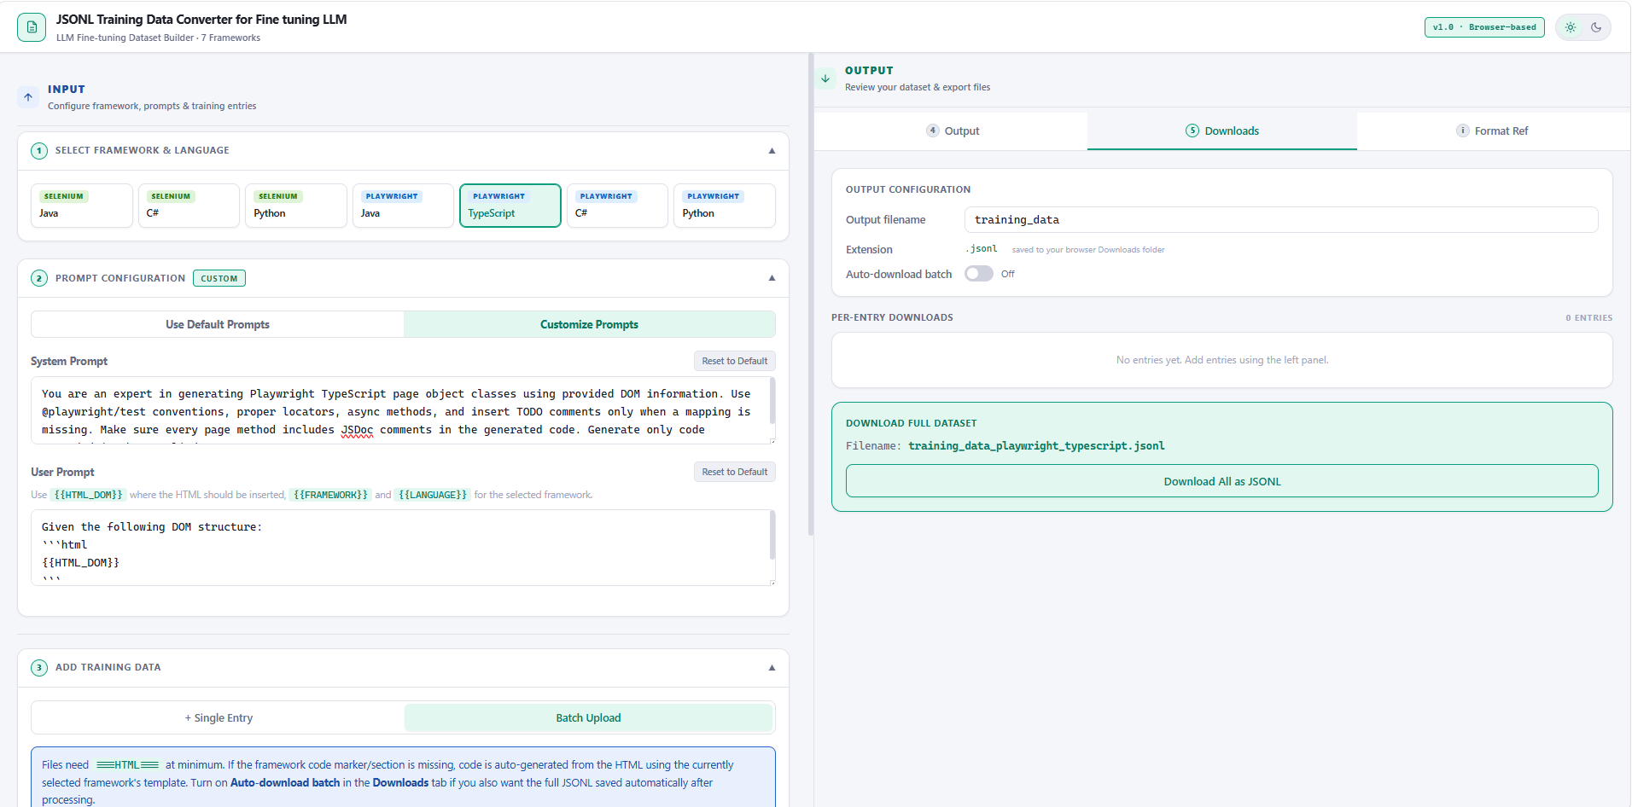

- Jsonl file generated
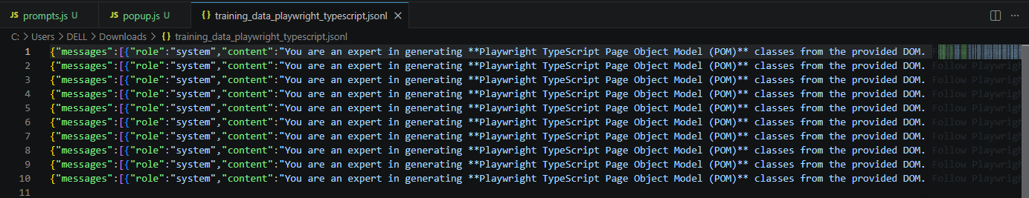

- Upload the file to Storage section under (api.testleaf.com)

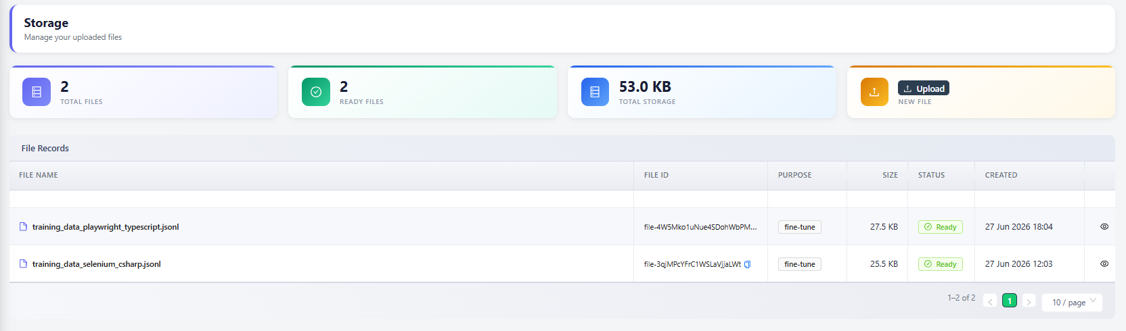

- Fine tune the model
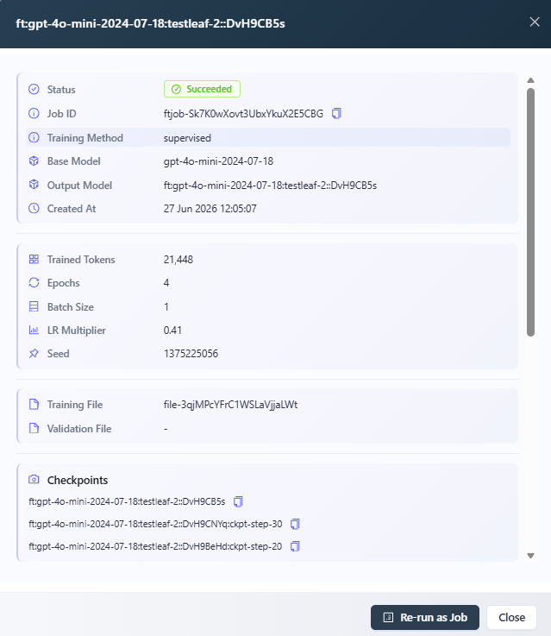

- Create API key
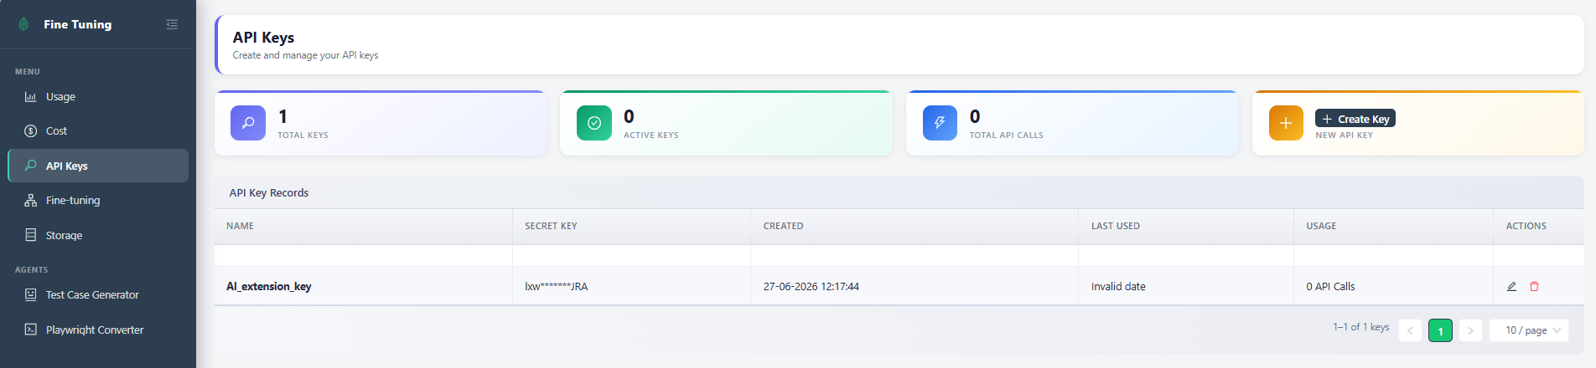

- Added the fine-tuned model in ‘popup.js’
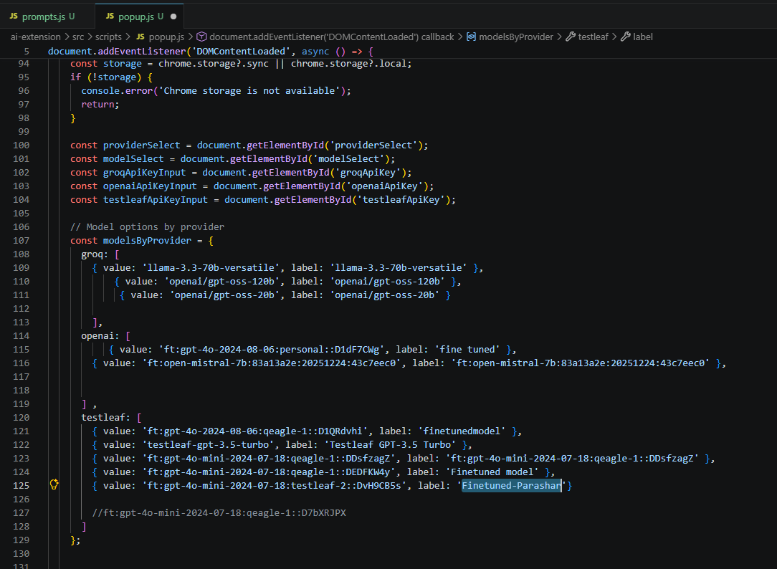

- The newly added model is displayed in the extension's Select Model list and fully supports Playwright with TypeScript code generation using Vibe Coding.

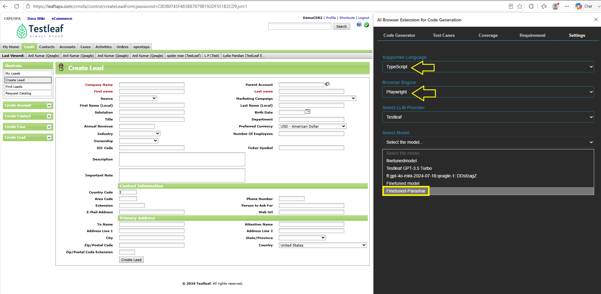

- Able to generate page class with the fine-tuned model
